Happy Ending
Mika

Band-Arrangement

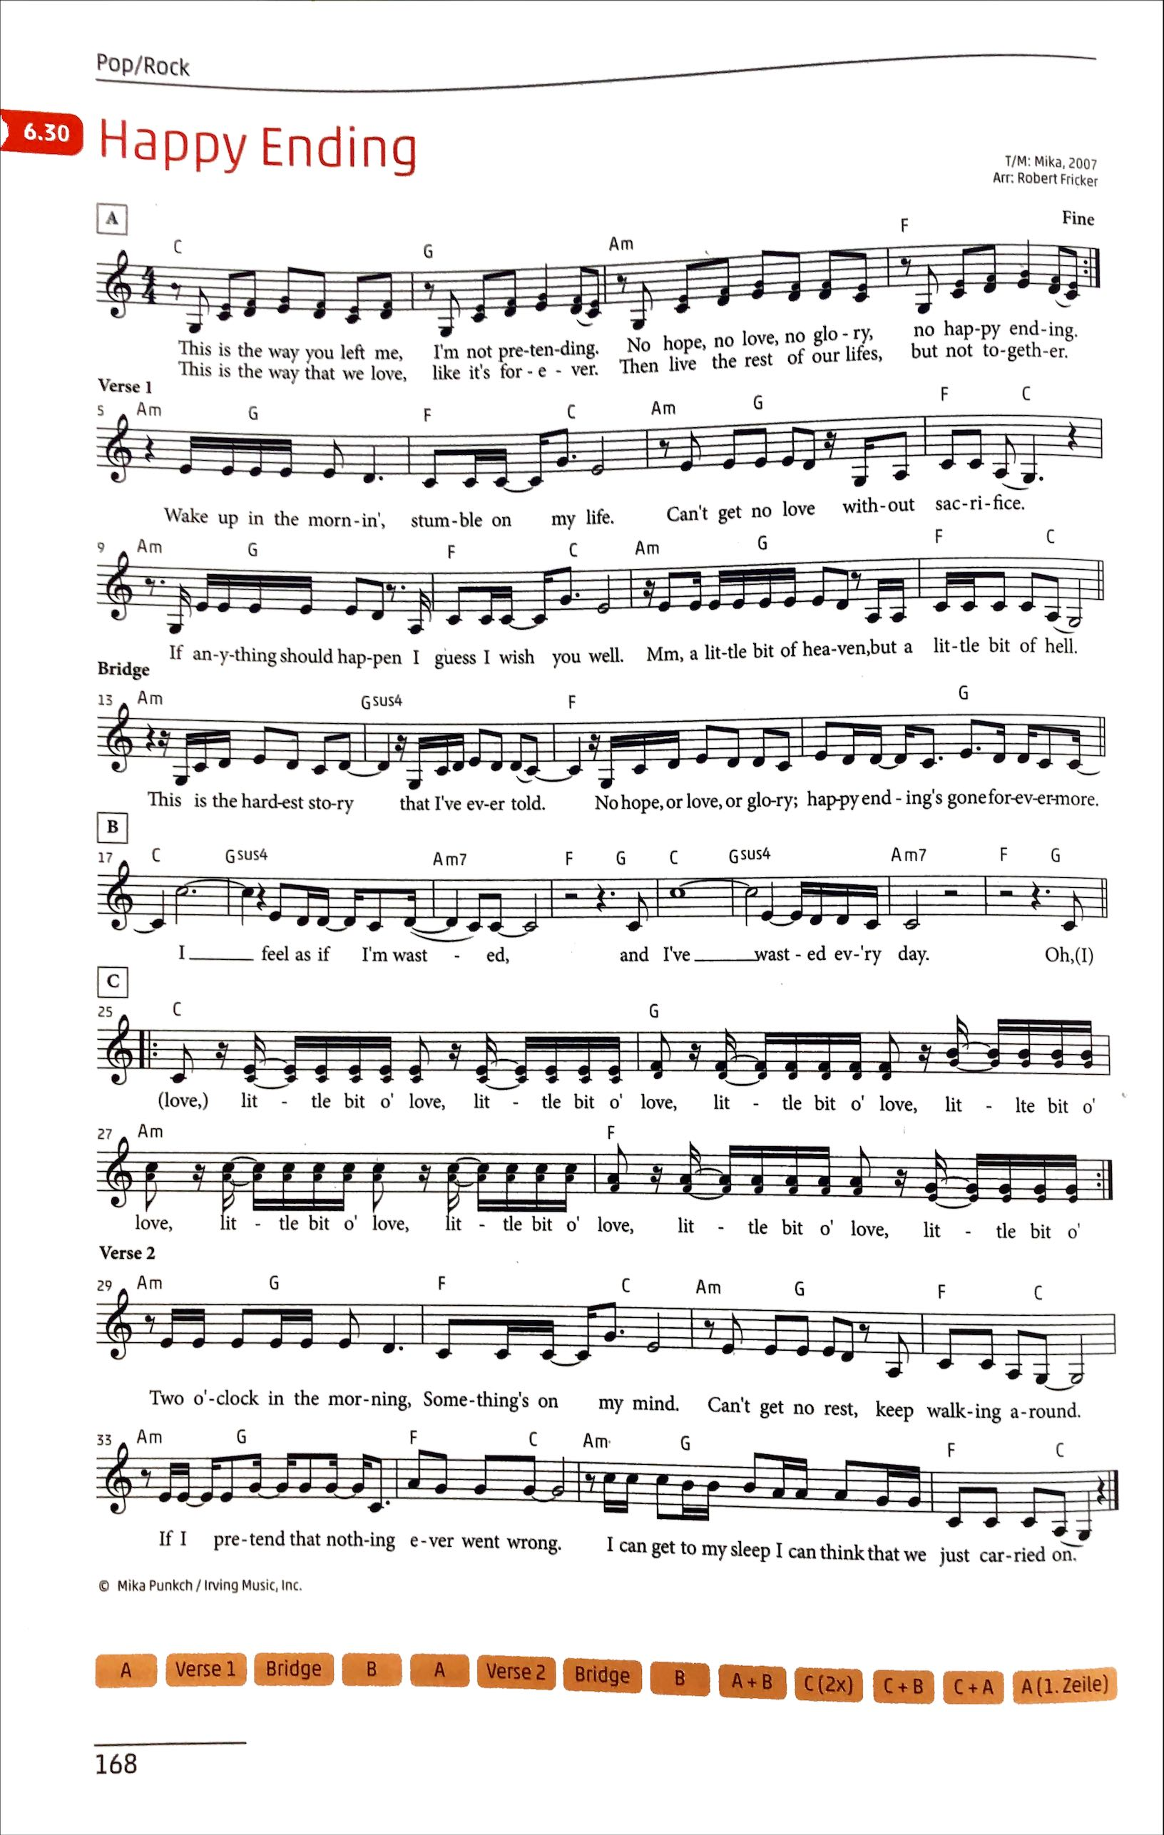
Pre-Chorus
Chorus
Drums

 | 1 | + | 2 | + | 3 | + | 4 | +
HiHat | x | x | x | x | x | x | x | x
Snare Drum |  |  | x |  |  |  | x
Bass Drum | x |  |  |  | x

Als Vereinfachung können HiHat und Snare/Bass auf zwei Personen verteilt werden

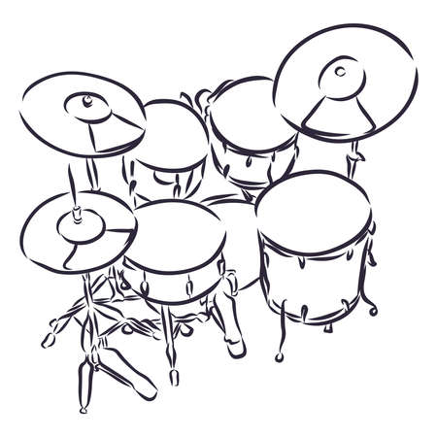

Piano rechts (Akkorde)
Pre-Chorus
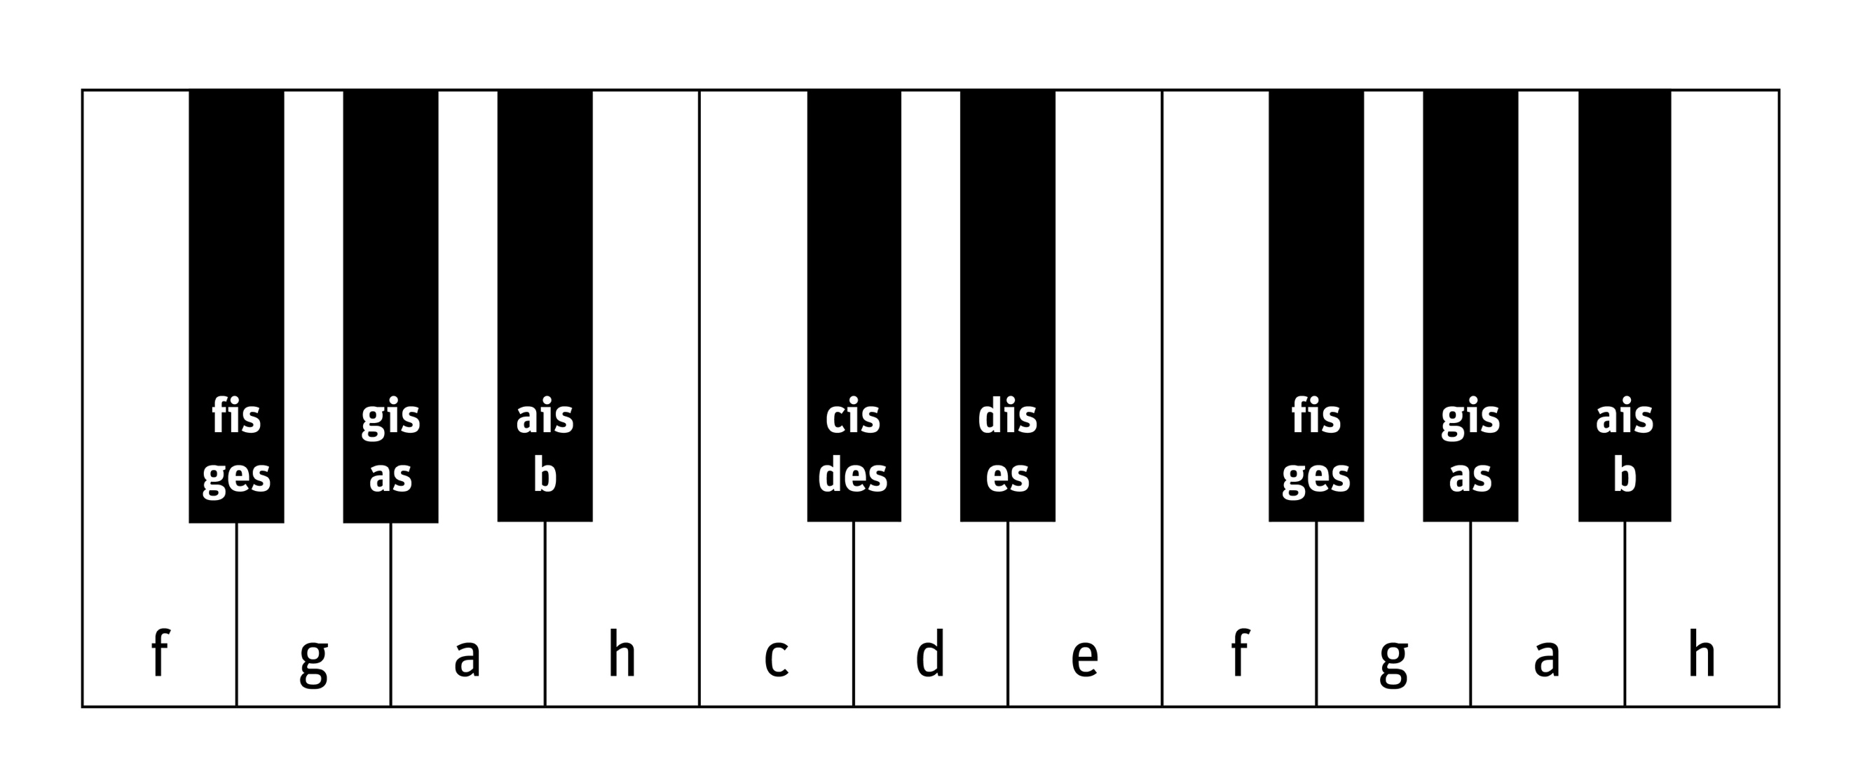

Chorus

Farben
Am G F F G

Pre-Chorus 1 2 3 4 1 2 3 4 1 2 3 4 1 2 3 4

C G Am F

2x Chorus 1 2 3 4 1 2 3 4 1 2 3 4 1 2 3 4

Piano links (Bass)
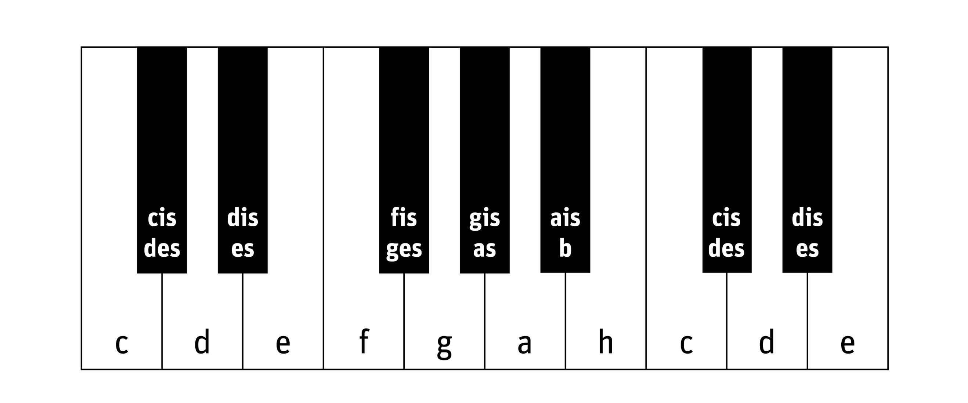

Farben
Am G F F G

Pre-Chorus 1 2 3 4 1 2 3 4 1 2 3 4 1 2 3 4

C G Am F

2x Chorus 1 2 3 4 1 2 3 4 1 2 3 4 1 2 3 4

E-Bass
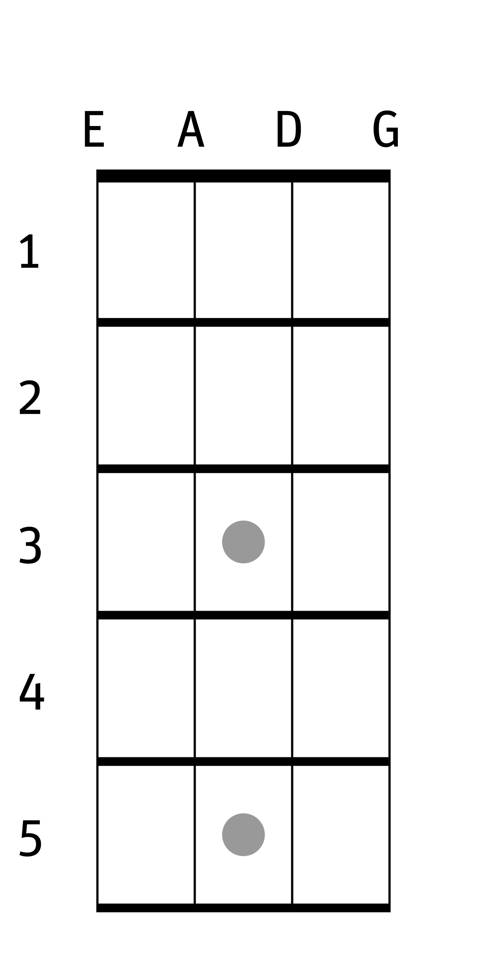

Bund
Saiten (E-Saite = Saite ganz oben)

Farben

Pre-Chorus 1 2 3 4 1 2 3 4 1 2 3 4 1 2 3 4

2x Chorus 1 2 3 4 1 2 3 4 1 2 3 4 1 2 3 4

Saite/Bund

E/5 E/3 E/1 E/1 E/3

Pre-Chorus 1 2 3 4 1 2 3 4 1 2 3 4 1 2 3 4

A/3 E/3 E/5 E/1

2x Chorus 1 2 3 4 1 2 3 4 1 2 3 4 1 2 3 4

Chor
2x Chorus
Bridge
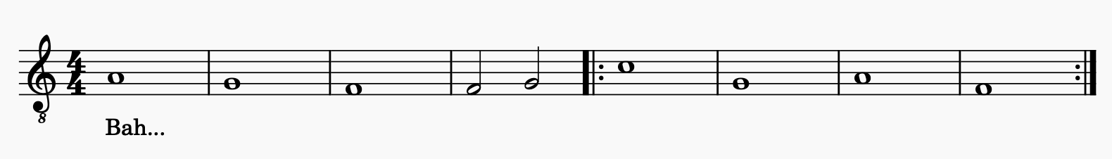

Farben

Pre-Chorus 1 2 3 4 1 2 3 4 1 2 3 4 1 2 3 4

2x Chorus 1 2 3 4 1 2 3 4 1 2 3 4 1 2 3 4

Zur Hilfe Audiofile bereitstellen E-Learning Musik Aktiv

Text
Intro
This is the way you left me, I'm not pretending
No hope, no love, no glory, no happy ending
This is the way that we love, like it's forever
Then live the rest of our life, but not together

Vers 1
Wake up in the mornin', stumble on my life
Can't get no love without sacrifice
If anything should happen, I'd guess I wish you well
Mmh, a little bit of Heaven, but a little bit of Hell
Solo-Stimme
Pre-Chorus
This is the hardest story, that I've ever told
No hope, or love, or glory, happy ending's gone forevermore

Chorus
(And) I feel as if I'm wasted
And I'm wastin' every day

Intro

Vers 2
Two o'clock in the morning, something's on my mind
Can't get no rest, keep walking around
If I pretend that nothing ever went wrong
I can get to my sleep, I can think that we just carried on

Pre-Chorus

Chorus

Oh love…
Bridge
Little bit of love
Chorus

End
This is the way you left me, I'm not pretending
No hope, no love, no glory, no happy ending

